**CIS 375 – Fall 2019 Term Project - BRAINS**



Use Case Specification Document

**5**

**Report Management**

**Version No. 1.1.0**

**Project Document Revision History**

|  |  |  |  |
| --- | --- | --- | --- |
| **VersionNumber** | **Date** | **Revision Author** | **Description of Revision** |
| 1.0.0 | 10/27/2019 | Muaz Alhaidar | Creation of document. |
| 1.1.0 | 10/30/2019 | Muaz Alhaidar | Changed the swim lane diagram rewrote the paths to reflect diagram. |

|  |
| --- |
| **Table of Contents** |

1. Introduction 4

2. Use Case Information 4

2.1 Actors 4

2.2 Use Case Interaction 5

3. Trigger 5

4. Pre-condition(s) 5

4.1 A Department has already been created 5

4.2 The user is logged in as an Oversight Team member 5

5. Post-condition(s) 5

5.1 A STENER is created and a due date is scheduled 5

5.2 A STENER is removed 5

5.3 A STENER is approved 5

5.4 A STENER is rejected 5

5.5 A STENER is updated (a change in the due date is considered an update of a STENER) 5

6. Use Case Swimlane (Activity) Diagram 6

7. Main/Basic Flow(s) of Events (Happy Path) 7

7.1 STENER is REMOVED 7

7.2 STENER is APPROVED 7

7.3 STENER is UPDATED 7

7.4 STENER is CREATED 8

7.5 STENER is REJECTED 8

8. Alternate/Exception Flow of Events 8

8.1 STENER is REJECTED (because it is past due) 8

8.2 STENER is not updated because is not unlike the previous STENER 8

9. Assumptions/Business Rules including Non-Functional Requirements 9

10. Use Case Specification Review and Signoff 9

# Introduction

This use case’s purpose is centered around the control and management of reports created by the Oversight Team and the questions answered by the Departments. It is the main method of how the Oversight Team will be dictating the work of the Departments on the reports in terms of approving or disapproving their work and changing what the Departments will be reporting on.

# Use Case Information

## Actors

An actor is someone or something (e.g. application system) outside the system or business that interacts with the application. For every Use Case, there must be at least one Main Actor and zero or more Secondary Actors. Actors should be a person, system, or time.

|  |  |  |
| --- | --- | --- |
| Actor Name | Role | Description |
| Data Base | Secondary | Stores all of the updated reports and due date values. If a report is removed by oversight, it will be removed from the database. |
| Oversight Team | Main | This team can create, remove, update, approve, reject, schedule to update, or set a due date of submission for a STENER report. |

## Use Case Interaction

How does this use case relate to other uses cases? List predecessor and successor use cases.

Predecessors:

1. Use case 1: ~
   1. STENERs need to be submitted by the departments in order to be rejected or approved.
   2. STENERs could be removed, and as such the answers will be deleted as well.
2. Use case 2: ~
   1. A user needs to login that has Oversight Team authorization in order to access this use case.
3. Use case 6: ~
   1. A department must be created before a STENER can be created
   2. Use case 6 also dictates whether or not a user will be able to access Use case 5 through whether or not the user has authorization to do so.

Successors:

1. Use case 4: ~
   1. Email notification will be sent when a new STENER is created.
   2. A readable version of the STENER and a STENER progress report can not be made until a STENER report is created.
   3. The readable version of the STENER and a STENER progress report will be removed if the report is removed by Oversight Team.

Purgatory:

1. Use case 3: ~
   1. By nature of this use case, it is inherently a subset of this use case in terms of creation and updating of the STENER.

# Trigger

A user logged in as an Oversight Team member attempts to create, remove, update, approve, reject, schedule to update, or set a due date of submission for a STENER report.

# Pre-condition(s)

What use cases or other pre-conditions must be met before use can initiate?

## A Department has already been created

## The user is logged in as an Oversight Team member

# Post-condition(s)

What are ALL the possible output states upon completion of the use case flows?

## A STENER is created and a due date is scheduled

## A STENER is removed

## A STENER is approved

## A STENER is rejected

## A STENER is updated (a change in the due date is considered an update of a STENER)

# Use Case Swimlane (Activity) Diagram

Draw diagram(s) that cover ALL main and alternate flows.

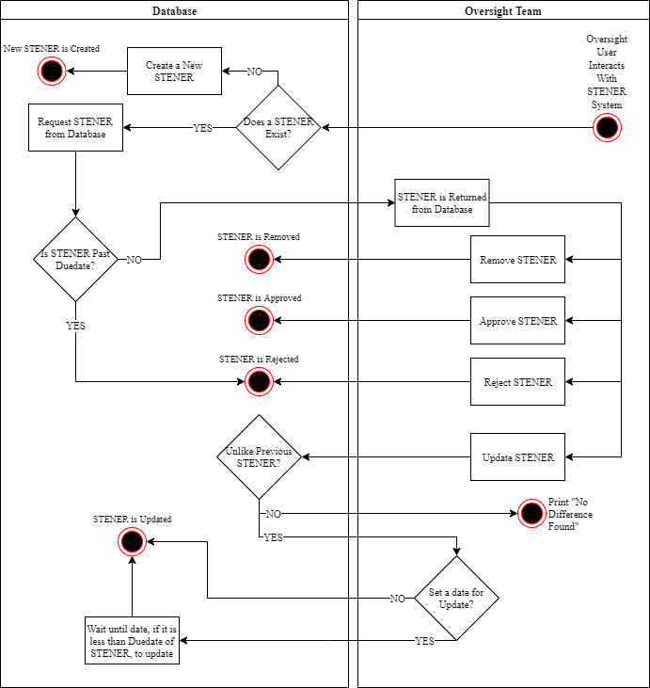

# Main/Basic Flow(s) of Events (Happy Path)

For each main flow (usually ONE flow) write the list of steps that occur – describe WHAT occurs not HOW to do it!

## STENER is REMOVED

* An Oversight Team user interacts with STENER system
* STENER exists in the Database
* STENER is requested from Database
* STENER is not past due date
* STENER is returned from the Database to Oversight Team
* Oversight Team removes STENER
* STENER is removed from Database

## STENER is APPROVED

* An Oversight Team user interacts with STENER system
* A STENER exists in the Database
* STENER is requested from Database
* STENER is not past due date
* STENER is returned from the Database to Oversight Team
* Oversight Team approves STENER
* STENER is approved in the Database

## STENER is UPDATED

* An Oversight Team user interacts with STENER system
* A STENER exists in the Database
* STENER is requested from Database
* STENER is not past due date
* STENER is returned from the Database to Oversight Team
* Oversight updates STENER
* Updated STENER is unlike previous STENER in the Database
* Oversight chooses whether or not to set a date (if they choose to set a date, the Database will wait until the date to move to the next step)
* STENER is updated in the Database

## STENER is CREATED

* An Oversight Team user interacts with STENER system
* A STENER does not exist
* Database creates a new STENER
* New STENER is Created.

## STENER is REJECTED

* An Oversight Team user interacts with STENER system
* A STENER exists
* STENER is requested from Database
* STENER is not past due date
* STENER is returned from the Database to Oversight Team
* Oversight rejects STENER
* STENER is rejected in the Database

# Alternate/Exception Flow of Events

For each alternative flow (can be zero or more) write the list of steps that occur – describe WHAT occurs not HOW to do it!

## STENER is REJECTED (because it is past due)

* An Oversight Team user interacts with STENER system
* A STENER exists
* STENER is requested from Database
* STENER is past due date
* STENER is rejected in the Database

## STENER is not updated because is not unlike the previous STENER

* An Oversight Team user interacts with STENER system
* A STENER exists in the Database
* STENER is requested from Database
* STENER is not past due date
* STENER is returned from the Database to Oversight Team
* Oversight updates STENER
* Updated STENER is not unlike previous STENER
* STENER is not updated and the system prints out “No Difference Found”

# Assumptions/Business Rules including Non-Functional Requirements

Be sure to number the assumption/business rules to allow easy reference to them. Business rules will be where non-functional requirements are recorded – have a way to specifically identify non-functional requirements.

# Use Case Specification Review and Signoff

|  |  |  |  |
| --- | --- | --- | --- |
| Review and Signoff of the Use Case Specification | | | |
| Name | Project Team Role | Signature | Date |
| Ahmed, Zakariya | Senior Tech Lead/SPMP manager | Z.A. | 10/30/19 |
| Alhaidar, Muaz | Developer | M.A. | 10/30/19 |
| Longworth, Kevin | Developer | K.L. | 10/30/19 |
| Labut, Cameron | Developer | C.L. | 10/30/19 |
| Majzoub, Mostafa El | Developer | M.M | 10/30/19 |